Desktop Support Chat

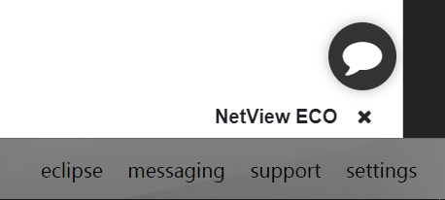

The Desktop Support Chat feature (pictured above) is located in the bottom right-hand corner of the main ActiveDesktop screen. It grants you access to an interactive chat that connects you directly to HBS Support personnel, who can answer your questions in real time.

**Chat Setup:** In order to use the chat, you will need to have a primary email address set up on your ActiveDesktop NetView user profile in the Settings screen. If you do not have one on record prior to opening the chat for the first time, the chat itself will prompt you for an address:

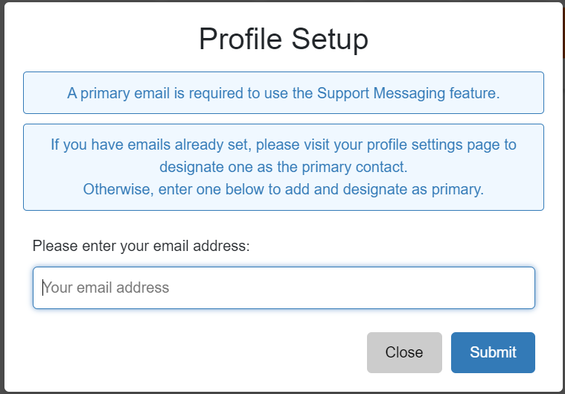

Enter your desired primary email address and click “Submit.” The system will automatically add this address to your user profile and set it as your primary address. You will then be able to access the chat feature.

**Using the Chat:** Click on the chat icon to open it.

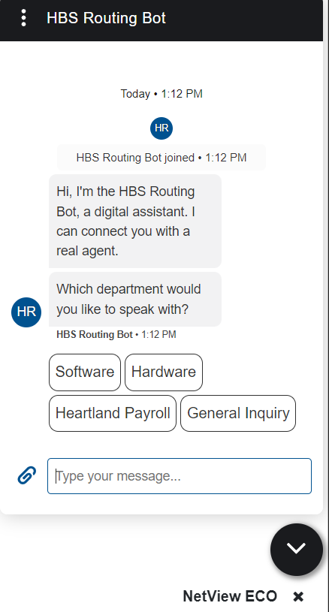

The HBS Routing Bot will automatically respond to offer you a set of Support topics that you may have questions on. Select one of the topics to have the bot connect you to an HBS Support Technician who can answer your questions on that topic. The chat window’s header will change to show you the name of the technician who you are speaking with once they connect and the Routing Bot drops out. Use the Message field at the bottom of the window to communicate with the Support Technician.

Attach File: If you need to send a file to Support as part of your conversation, such as a screenshot showing your current issue, use the “Attach File” icon next to the Message field to select the file and attach it.

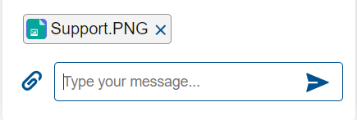

Hit “Send” to submit the file as you would any text message.

Show/Hide Chat: After you initially open the chat window, you will notice the chat icon has turned into a downward-pointing arrow:



Click on this to minimize the chat at any time, at which point the icon will look like this for an active chat:



Click on it again to re-expand the chat window.

End Conversation: Once you are done with your chat, click on the three vertical dots in the left corner of the chat window’s header to access the Support Messaging Menu:

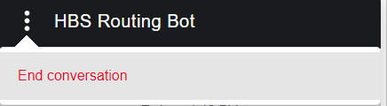

Click “End conversation” to end your chat and disable the messaging features. You can then use the “x” icon on the right side of the chat’s header to close the chat window.